My SQL Assignment

**Justit.co.uk**

**Submitted to:  
Vanita Silaparasetty.**

**5/15/2023**

Iram Saeed

15 May 2023

Contents

MY SQL ASSIGNMAENT 3

TASK 1 3

TASK 2 5

TASK 3 6

Creating an EER Diagram 6

Additional Query 7

1. Find the name of customers that have points between 1000 and 3500. 7

2. Find the name, address and city of customers who’s name last name start with “R”. 8

3. Find the customer id, and order date from orders having status 1. 9

4. Find total price of ordered items. 10

5. Find 10 most ordered item from order items. 11

6. Find the maximum unit price as costly unit. 12

# MY SQL ASSIGNMAENT

## TASK 1

Using the Query 2 you created change the points to reads times by 10 and plus 100. Record your results in your word document

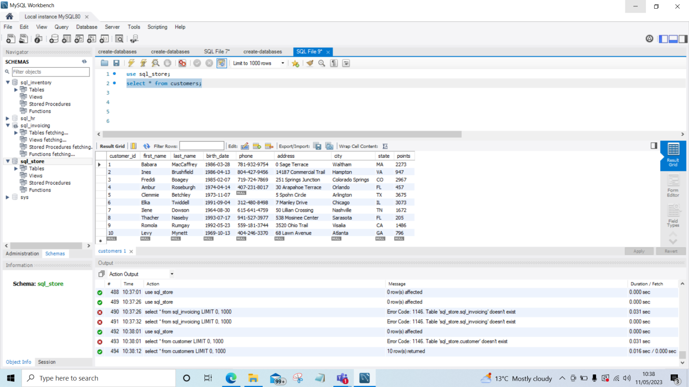

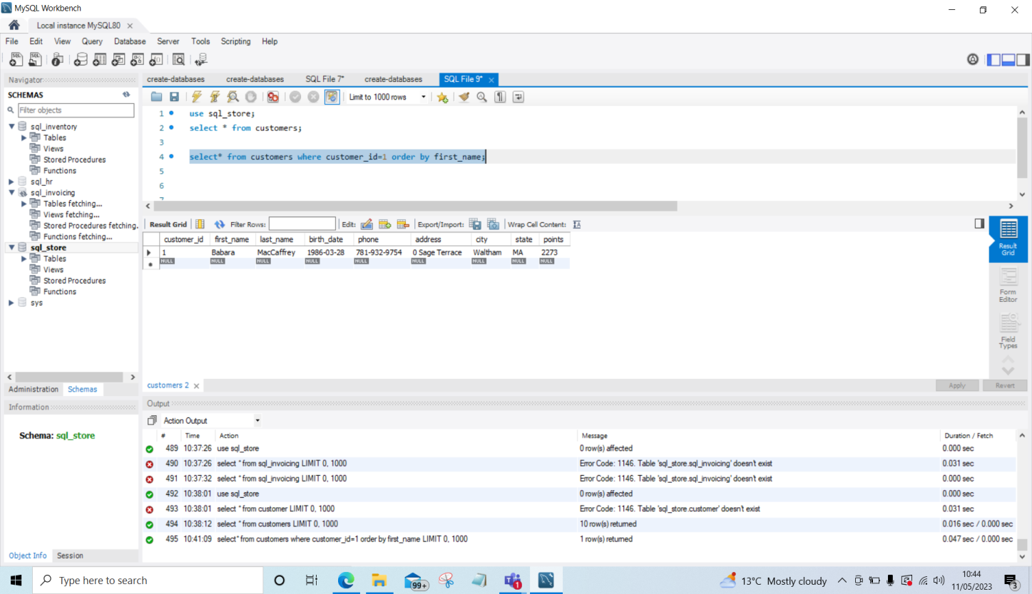

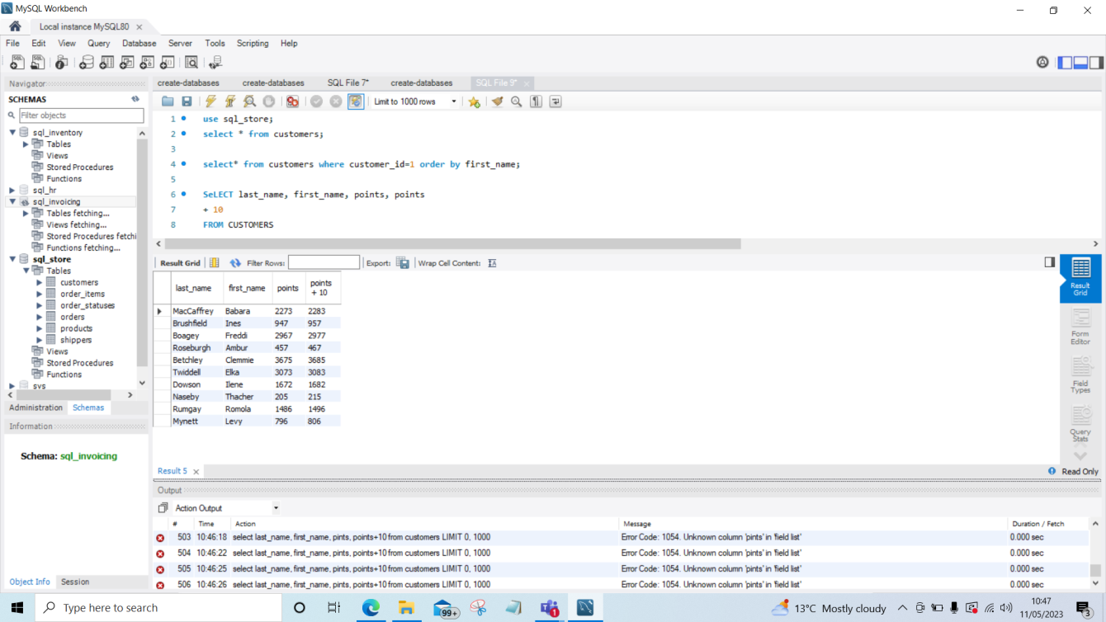

Using the Query 2 you created change the points to reads times by 10 and plus 100. Record your results in your word document.

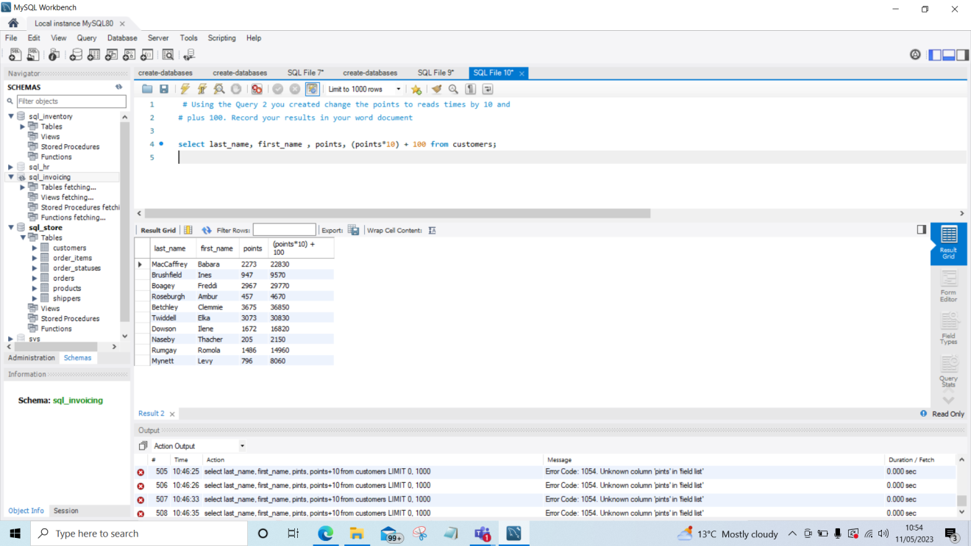

Change the Query 2 code to create a discount factor so the table now shows a discount header and changing the (point + 10) *100

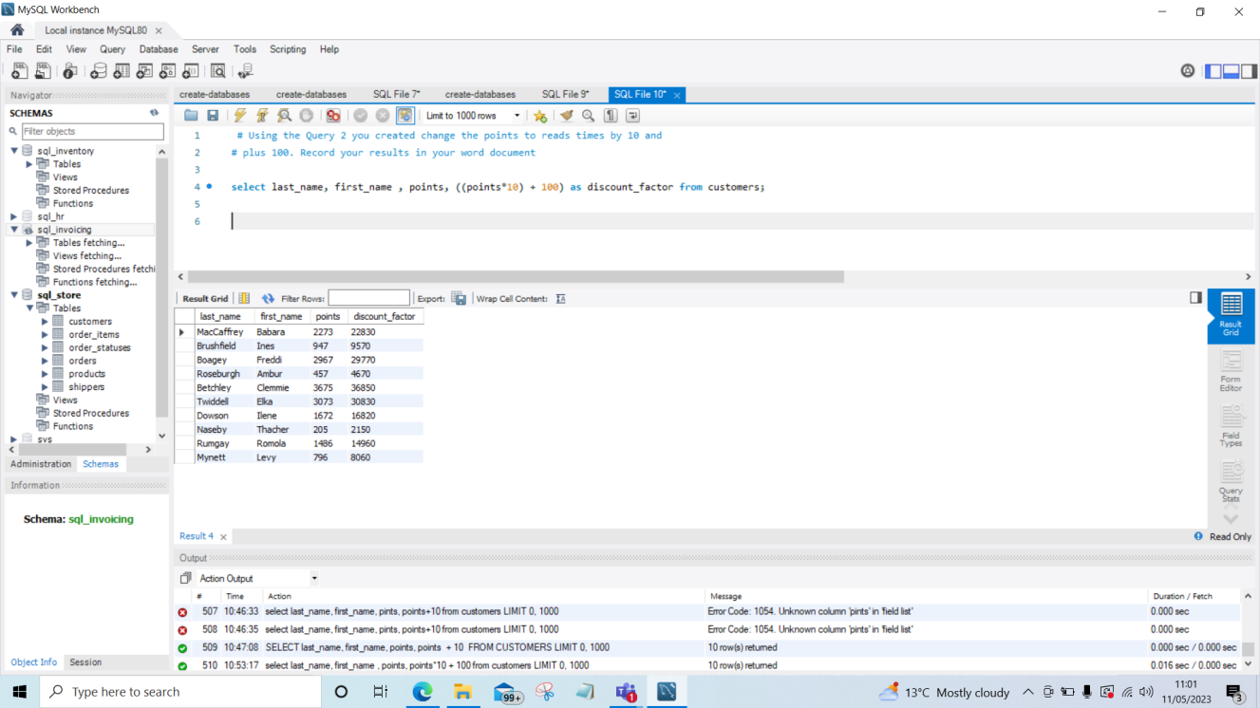

## TASK 2

Write a SQL query to return all the products in our database in the result set. Show three columns, name, unit price, and new column called new price which is based on this expression, (unit price * 1.1 ). So what you are doing is increasing the product price of each by 10%. So with the query we want all the products the original price and the new price.

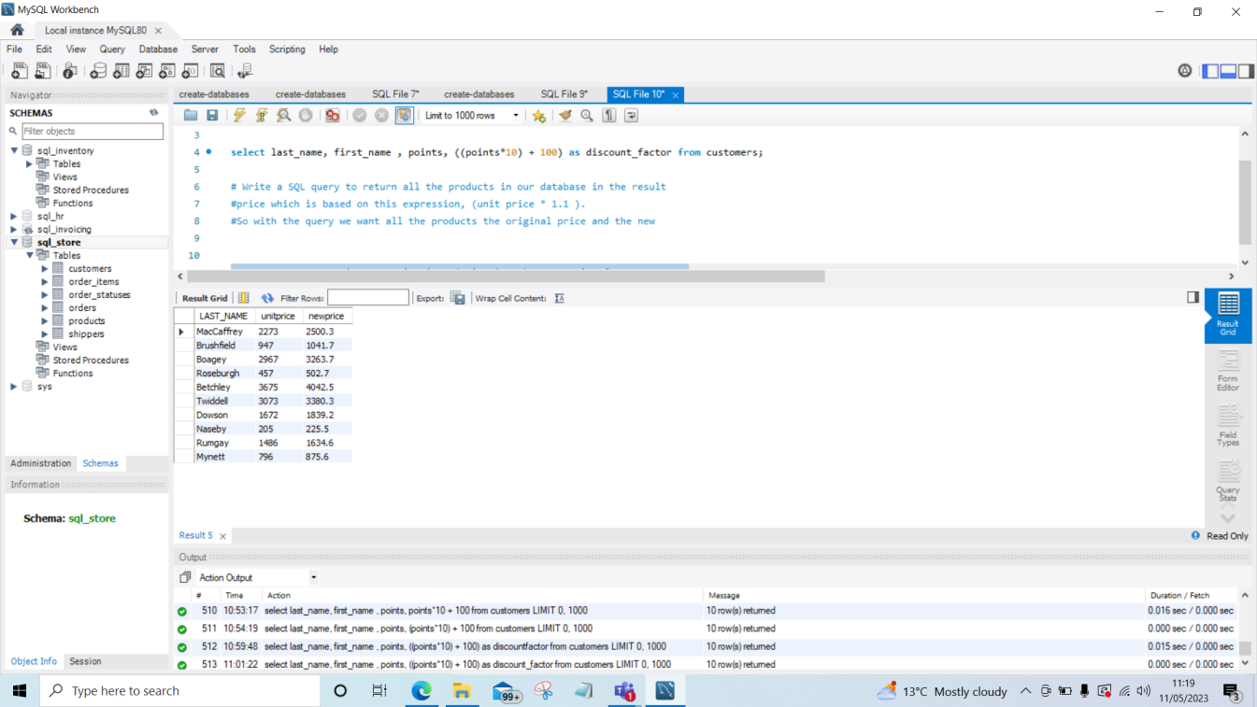

## TASK 3

In this task create a new query to find all the customers with a birth date of > '1990-01-01' • Enter the following:

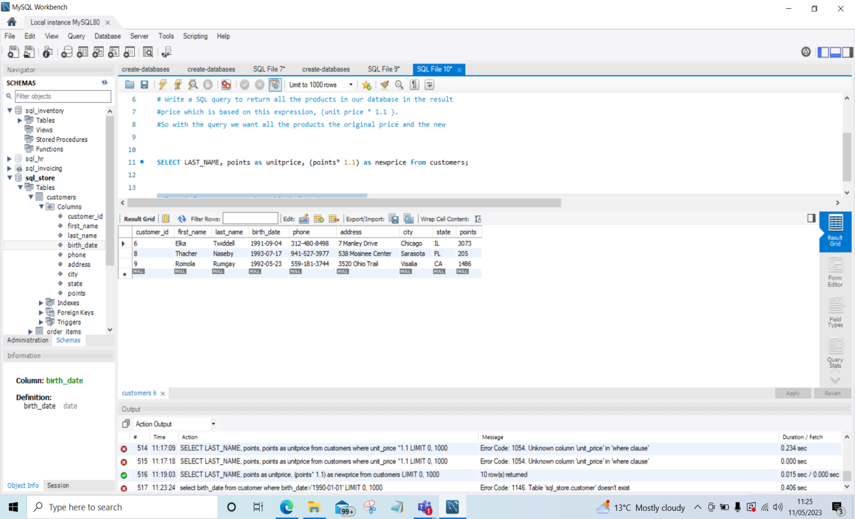

## Creating an EER Diagram

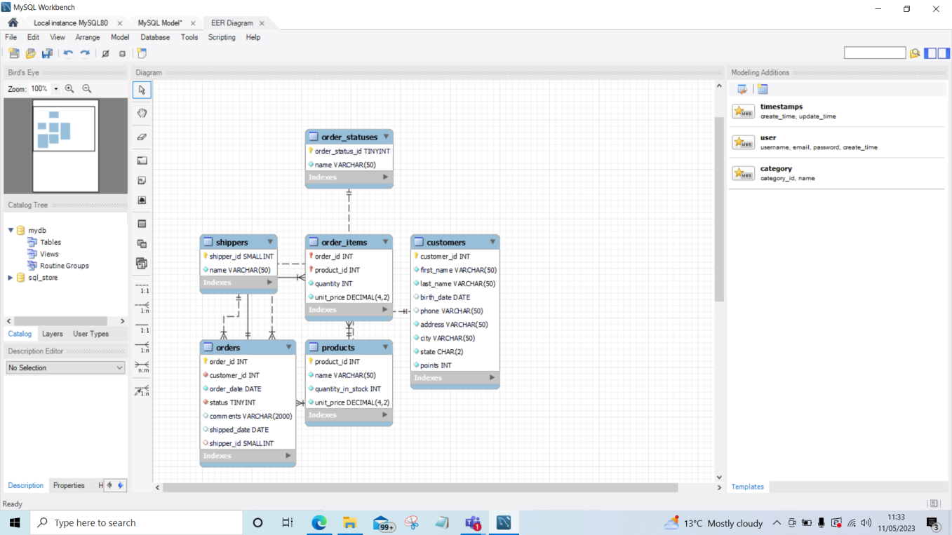

# Additional Query

## Find the name of customers that have points between 1000 and 3500.

select first_name, last_name, city, points from customers where points >1000 and points < 3500;

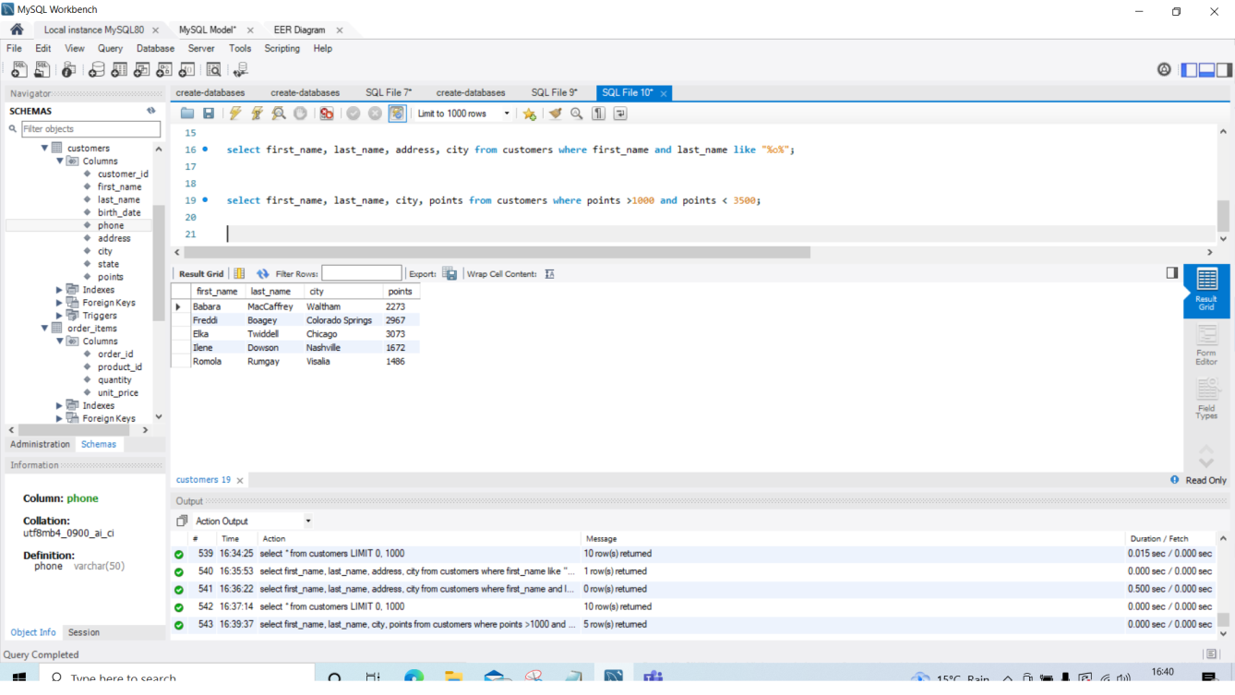

OR

select first_name, last_name, city, points from customers where points between 1000 and 3500;

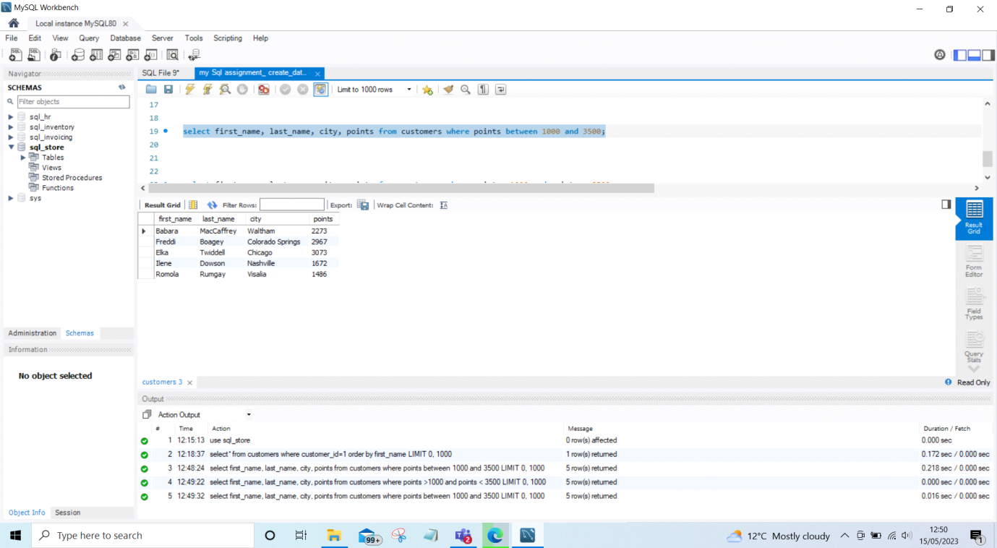

## Find the name, address and city of customers who’s name last name start with “R”.

select first_name, last_name, address, city from customers where last_name like "r%";

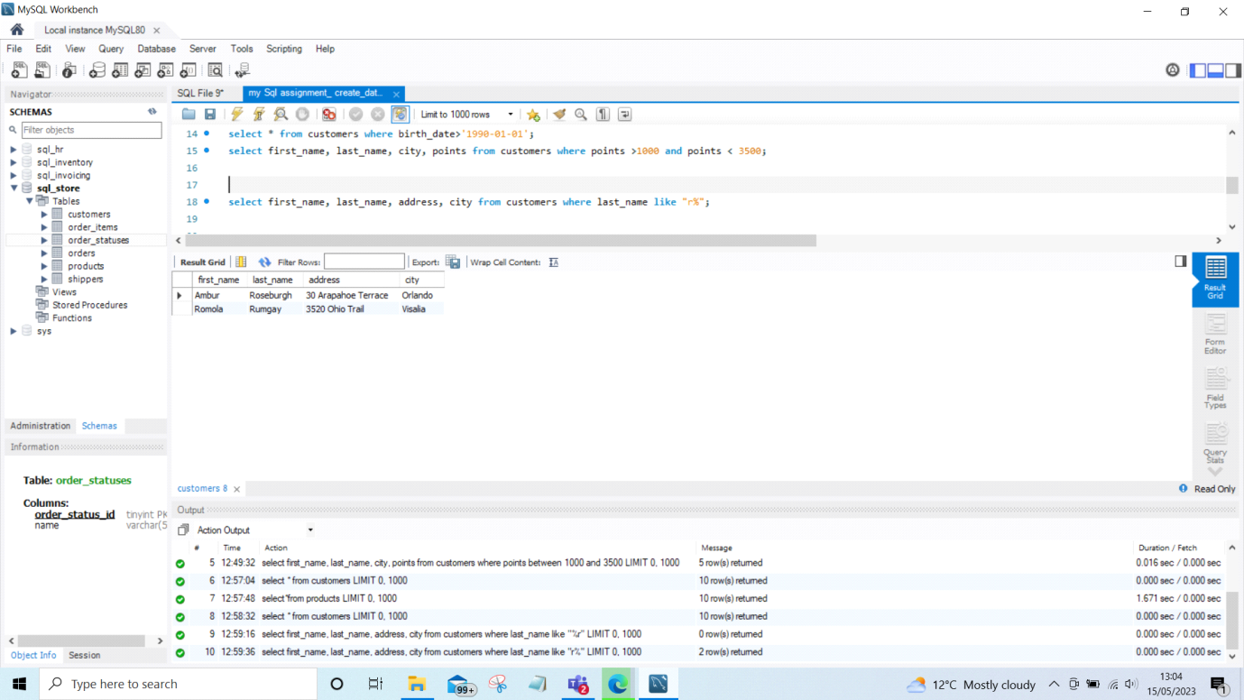

## Find the customer id, and order date from orders having status 1.

select order_date , customer_id, status from orders where status=1;

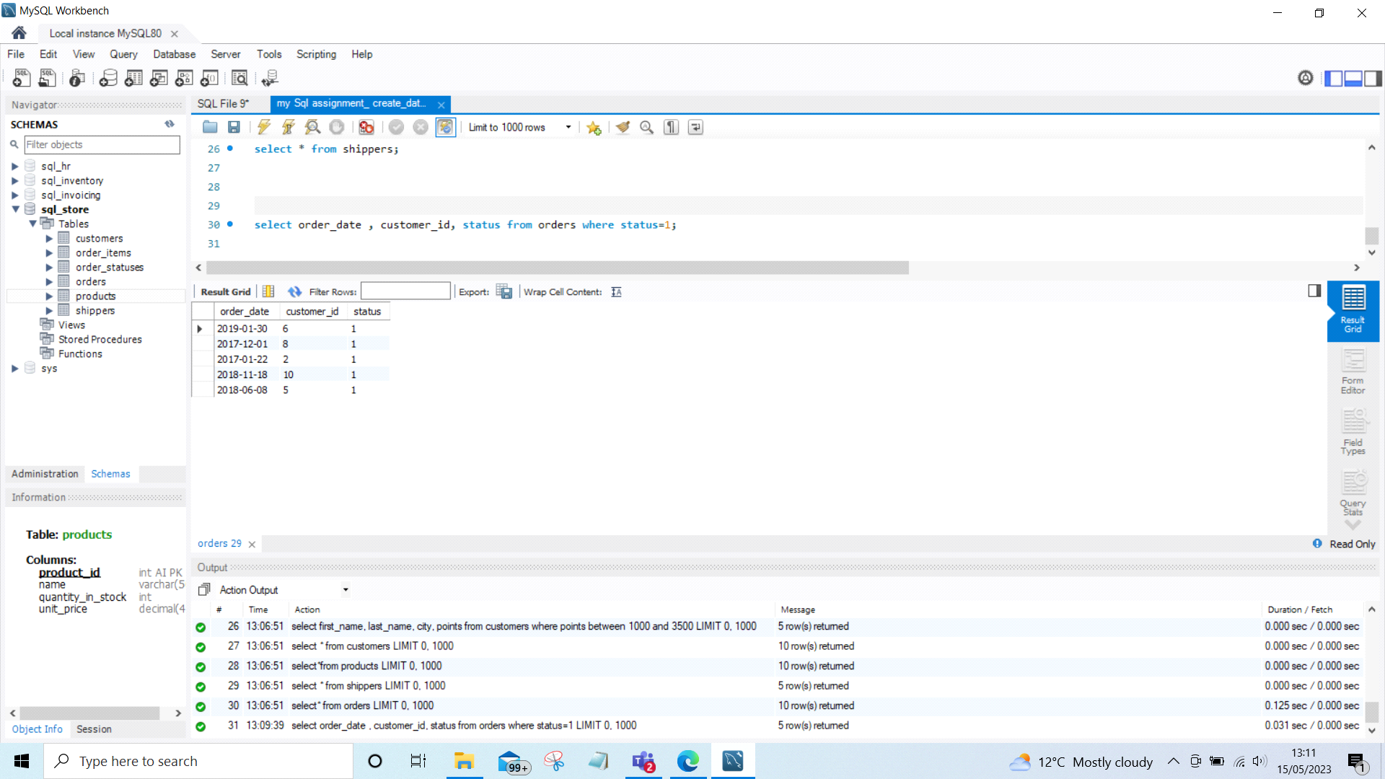

## Find total price of ordered items.

select *, (unit_price * quantity)astotalprice from order_items;

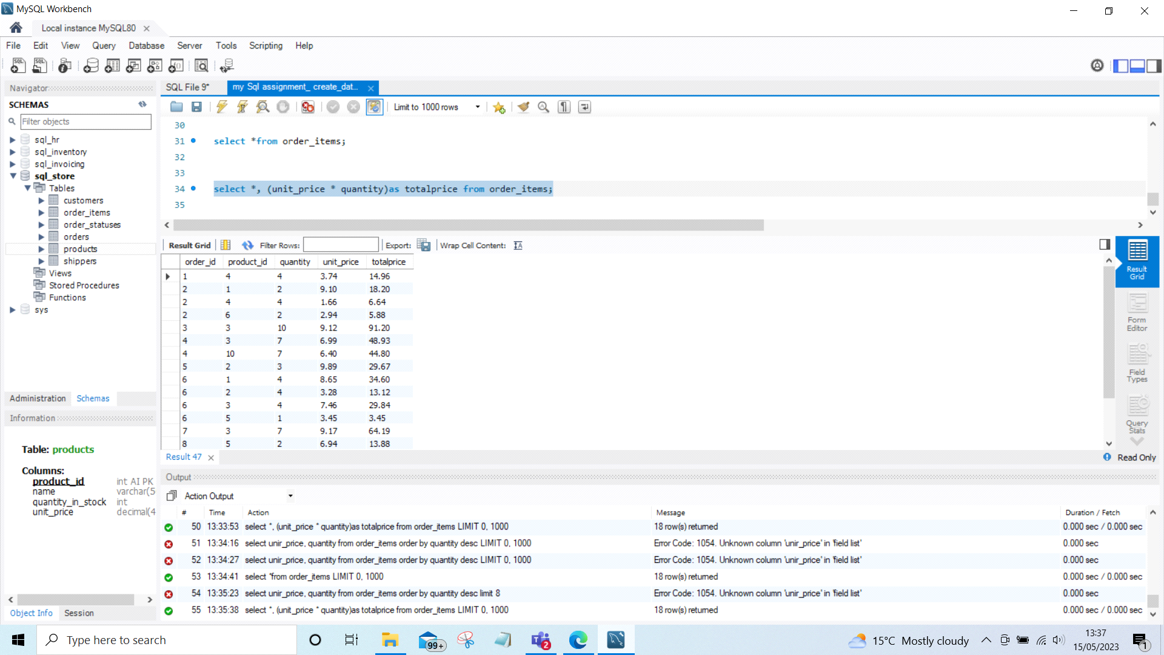

## Find 10 most ordered item from order items.

select * from order_items order by quantity desc limit 10;

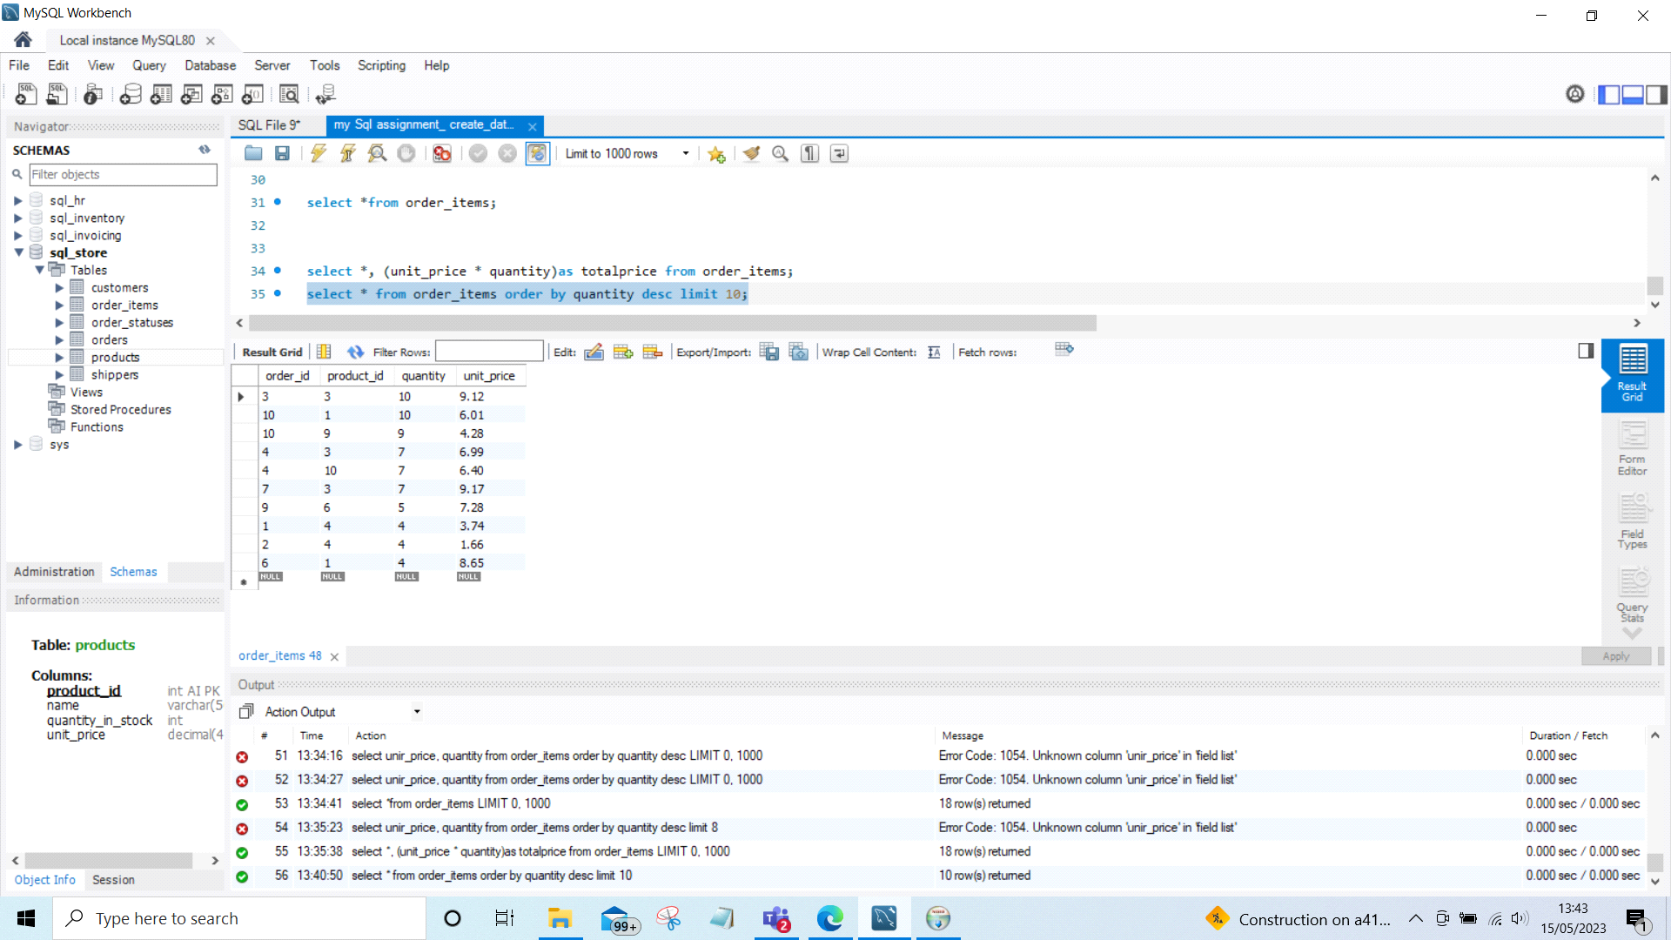

## Find the maximum unit price as costly unit.

select max(unit_price)as costlyunit from order_items;

